**Wire arc additive manufacturing of aluminium alloys: A Review**

**Vimal K E K and Naveen Srinivas**

**Department of Mechanical Engineering**

**National Institute of Technology, Patna**

**Abstract**

Wire and arc additive manufacturing (WAAM) is the most advanced technique used to fabricate desired part through layer-by-layer deposition of material. WAAM can produce medium and large sized components with higher deposition rates, low manufacturing cost and less production time. Mechanical and metallurgical properties of WAAM based products are much better and suited for aerospace engineering. WAAM is still under examination because of challenges like porosity, corrosion, delamination, residual stresses and oxidation. From the literature review, it has observed that the metals like titanium, aluminum, steels and nickel-based alloys can be used in WAAM process. In this paper, the various technologies and process advancements such as inter pass cold rolling, inter pass cooling, peening effect and weld pool oscillation have been discussed in detail. Finally, an in depth about WAAM of aluminum alloys and metallurgical and mechanical properties have been discussed. Based on the above review, various problems associated with WAAM of aluminum alloys and the strategies to address the issues are presented.

***Keywords***: WAAM; aluminium alloys; TIG; MIG; process advancements

**1. Wire arc additive manufacturing (WAAM)**

Wire and arc additive manufacturing is the most advanced technique used for additive manufacturing of metals. In this process, the wire is used as feed material and arc as the power source. The welding torch / power source, wire feeding mechanism and computer control base, are the main components of the WAAM system. The computer control system is used to control the wire feed and arc generation to facilitate controlled metal deposition to produce desired objects. In the WAAM process, the desired part is fabricated through layer-by-layer [1] deposition of material. Comparing with the conventional additive manufacturing process, the mechanical and metallurgical properties of a WAAM based products are much better and they are suited for aerospace engineering materials. Tungsten inert gas welding, metal inert gas welding and cold metal transfer welding are the different welding techniques using for deposition of metals. Deposition rate of metal wire in WAAM process is around 15-130 gr/min which is higher than the conventional additive manufacturing process [2]. Cost of WAAM fabricated material can be reduced by 7- 69% [3]. Fabrication time can be reduced by 40-60% and post-machining time can be reduced by 15-20% [4]. Mechanical and metallurgical properties of WAAM deposited material can be further improved by post processing treatments. The generic scheme of WAAM process is presented in Figure 1.

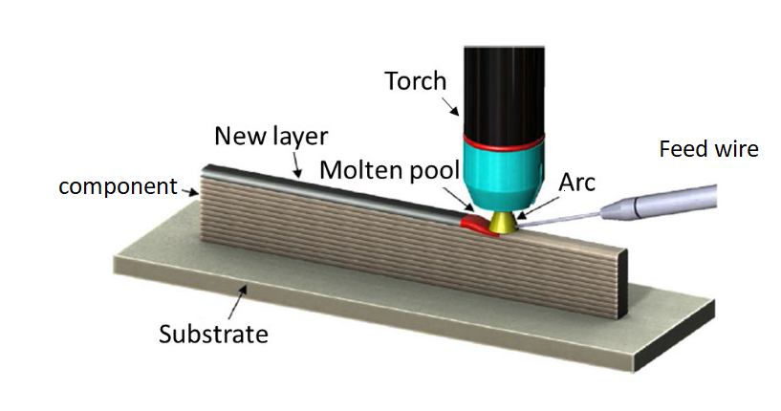

**Fig.1. Basic WAAM process [5].**

Complete WAAM process involves three steps namely process planning, metal deposition, and post processing. Process planning [6,7,8] includes- 3D CAD model generation, slicing 3D CAD model into set of 2D geometries, generating tool path for each of these 2D geometries, setting deposition parameters for each layer, choosing welding parameters like travel speed, feed rate, voltage, etc. Finally, the product can be deposited by WAAM process with given input parameters and tool path. Post-processing is a set of methods which are used to improve the metallurgical and mechanical properties [4]. Fig.2 representing the operational description of whole WAAM process.



**Fig.2. Operational description of WAAM process [7].**

In this paper, in depth review have been presented on various slicing and tool path generation methods, details of various welding methods used in WAAM and process modifications/ advancements to address the changes in WAAM. With reference to the above review, the application of WAAM on aluminum alloys were discussed in detail.

**2.Slicing and tool path generation**

Methods available to slice 3D model into 2D geometries are unidirectional slicing and multidirectional slicing. It’s very difficult to use unidirectional slicing method for components with complex shapes, for those complex shapes multidirectional slicing methods are preferable [9]. Available multidirectional methods are transition wall slicing, surface tension slicing, centroid axis extension slicing, projection-based decomposition, offset slicing, modular boundary model and decomposition regrouping. Table 1 Indicates different slicing methods with suitable models. Proper tool-path generation can improve weld bead geometry and surface accuracy of parts. Different types of pattern tool paths are raster, zigzag, contour, spiral, fractal space filling curves, continuous, hybrid, MAT-based and adaptive MAT. Table 2 Indicates different types of tool paths

**Table 1. Types of multidirectional slicing methods with suitable models.**

|  |  |
| --- | --- |
| **Slicing method** | **Example** |
| Silhouette edges  Projections [10] |  |
| Centroid axis  Extraction [9][11] |  |
| Transition wall [9] |  |
| Decomposition  Regrouping [12] |  |
| Surface tension [13] |  |
| Offset slicing [14] |  |
| Projection based  Decomposition [10] |  |

**Table 2. Tool path generation methods.**

|  |  |  |  |
| --- | --- | --- | --- |
| **Pattern**  **tool**  **path** | **Examples** | **Pattern tool**  **path** | **Examples** |
| Raster [15] |  | Continuous [21] |  |
| Zigzag [16][17] |  | Hybrid [22] |  |
| Contour [18] |  | MAT-based [23] |  |
| Spiral [19] |  | Adaptive MAT [24] |  |
| Fractal space filling curve [20] |  |  |  |

Busachi et al. [25] designed the integration definition of function modeling (IDEFO) for the better visualization of operations, mechanisms, inputs, outputs given to the WAAM system. The main function of IDEF0 is to provide basic understanding of WAAM. Fig.3 shows basic WAAM IDEF0 system [25].

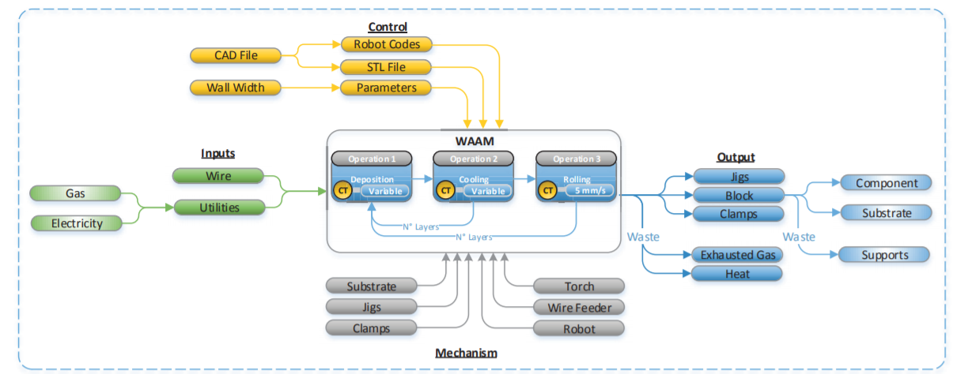

**Fig.3. IDEF0 system [25].**

**3 Different welding methods used in WAAM process**

In WAAM, the process used to generate arc are gas tungsten arc welding (GTAW), gas metal arc welding (GMAW) [26], cold metal transfer (CMT) [27]and plasma arc welding (PAW) [28]. In the following subsection, the details of each process have been discussed.

**3.1 GTAW based WAAM process**

In gas tungsten arc welding based additive manufacturing process tungsten metal rod is used as electrode with inert gases such as argon, helium, etc., for shielding [29][30]. In most of the cases argon is used as the shielding gas. The main purpose of shielding gas is to prevent the deposited material from the oxidation, corrosion and fusion defects [31] [32]. It also acted as heat carrier for tungsten electrode and helps to maintain stable arc. Argon shielding gas provides smooth and quite operation and it is easy to handle when compared with the arc obtained by helium shield gas. Pure argon is used for structural steels, low alloyed steels, stainless steels, titanium and magnesium. Pure helium is used for aluminum and copper. Mixer if argon and hydrogen is used for some grades of stainless steels and nickel alloys. Mixture of helium and argon is used for alloys steels, aluminum and copper. Size of the welding torch nozzle depends upon on the amount of shielding area [33]. Size of the gas nozzle depends upon the diameter of electrode. Diameter of electrode should be three times less than the diameter of nozzle. Materials used for nozzle are aluminum and ceramic materials. Uniform arc can be maintained by maintaining uniform distance between the tip of the electrode and base plate or previously deposited layer. In this process the electrode is a non-consumable, this separate mechanism is used to feed the wire. In GTAW process wire can be feed in three directions (back feed, front feed and side feed). Quality of deposit also depends upon the wire feed direction. The GTAW based WAAM process is widely used for materials such as titanium, aluminum, steel, copper and magnesium. Deposition rate of wire metal during the process is around 1-2 kg/hr. [33]. Further, GTAW is divided into two types. Namely, one-wire GTAW and twin-wire GTAW based WAAM process [34]. Fig.4 Presents the one-wire GTAW based WAAM process.



**Fig.4. One-wire GTAW based WAAM process [35].**

One-wire GTAW based WAAM system mainly consists of wire feeder, power source, robot, welding torch and other WAAM parts. Firstly, 3D model is fed to the computer, then 3D model is divided into number of 2D layers. Based on 2D layer contour, the final path of the torch will be decided [36]. Robot can move the torch as per the decided path and based on welding parameters (deposition rate, feed rate, speed of travel). After first layer is deposited on the base plate (substrate), torch can move to certain height for providing space for post-treatment process (inter layer rolling, heat treatment, etc.) if required. After some dwell time second layer is deposited on the first layer which acts as a substrate for the second layer. This procedure can be repeated till the torch reaches its final position.

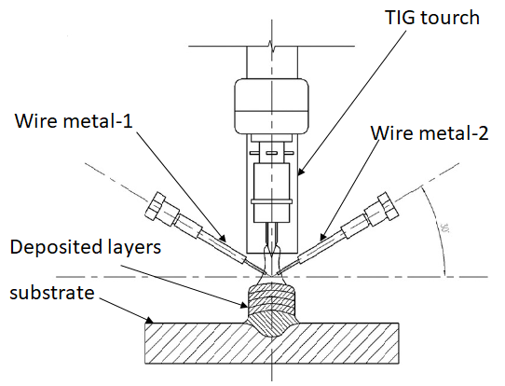

**Fig.5. Twin-wire GTAW based WAAM process [37].**

Twin-wire GTAW based WAAM process is also similar to one-wire GTAW based WAAM process except that wire feeding mechanism. Two different type of wire materials or two same type of wire materials can be used to produce final product. Two feed wires are fed into the weld pool by the help of two separate wire-feed systems. Composition of final product can be adjusted by adjusting the wire feed rates separately. Fig.5 represents the basic principle of twin-wire GTAW based WAAM process. In order to get proper deposition rates and to obtain better mechanical properties torch is maintained perpendicular to the base plate and two wires fed with an angle of 30° from the base plate [38]. The main purpose of twin-wire WAAM process is to produce inter metallic and functionally graded materials, and also it can be used where higher metal deposition rate should be required.

**3.2 Gas metal arc welding based WAAM process**

GMAW based WAAM process mainly consists of a robot, wire feeding motor drive, welding equipment, and computer controller. The electrode used is a consumable type and electrode itself acts as a deposition material. A wire can be fed into the weld pool, through copper contact tube, from the reel driven by the motor. The diameter of feed wire is in the range of 0.6mm to 1.6mm [39][40]. Torch handle consists of trigger which controls the shielding gas, welding current, and feeding of wire. Aluminum, copper, steel, titanium brass and nickel alloys can be fabricated using GMAW based WAAM process. Welding torch nozzle is used to provide the shield gases on to the deposited material to protect deposits from the oxidation due to atmospheric gases. The selection of shield gas is depending upon the type of depositing wire material. For non-ferrous metal pure inert gases can be used for shielding. For example, Argon, Helium, and mixture of Argon and Helium can be used for aluminum, copper and nickel alloys. The mixture of Argon and 5% of oxygen, Argon and 25% CO2 are used for stainless steel [41]. For better deposition rates, the angle made by the electrode with the perpendicular position should be less than 15°. The angle greater than 20° results in spatter, less penetration and less arc intensity. Deposition rate is around 3-4kg/hr. [4]. Fig.6 represents GMAW based WAAM process.



**Fig.6. GMAW based WAAM process [41].**

There are three different types of metal transfer modes present in the GMAW process, 1) Short-circuiting or Dip metal transfer mode 2) Droplet or Spray metal transfer mode 3) Pulsed metal transfer mode. In short-circuiting or Dip type mode, the metal transfer can be achieved by dipping the molten metal formed on the tip of the feed wire into the weld pool. This can be achieved by maintaining a low voltage. In droplet or spray type mode, a metal transfer can be achieved by maintaining much higher voltage which can be obtained by creating short-circuiting with weld pool. Droplet which is formed on the tip of the feed wire is transferred to the weld pool through some kinetic energy, this can be achieved by providing forward and backward moment to the feed wire. In a pulsed type, the metal transfer can be achieved by creating pulses of current. each pulse has sufficient force to detach droplets from the feed wire.

**3.3 Cold metal transfer (CMT)**

CMT process is a modified version of GMAW based WAAM process [42]. The basic components of CMT-WAAM system are a robot, wire feeding motor drive, welding equipment, and computer controller. The main difference between the CMT and GMAW is the type of mechanism used for detachment of the metal droplets from the metal wire. The process is named as cold metal transfer because, the amount of heat generated in the CMT-WAAM process is much lesser than the heat generated by the conventional GMAW-WAAM process. A low spatter and controlled metal deposition rate can be possible due to low heat input [43]. In this method, all the processes are digitally controlled. Metal deposition rate is around 3.6 kg/hr [41].

When metal feed wire moves towards the substrate (Baseplate) arc is started at the tip of the metal wire. As the wire moves towards the weld pool, boosting of the arc can happen. When the tip of the feed wire touches the weld pool, a short circuit can develop in the system. At the time of the short circuit, the feed wire polled back up to a certain height. During this rearward movement of the wire, droplet detached from the wire and fed into the weld pool. Because of the short circuit during the time of deposition, less amount of heat is generating at the weld pool. It is the main advantage of this process. Advanced processes have been developed in CNC which includes CMT Pulse (CMT-P), CMT advanced (CMT-ADV) and CMT pulse advanced (CMT-PADV) [44]. Fig.7. indicates the mechanism of droplet deposition.

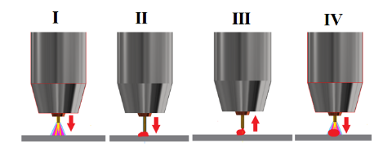

**Fig.7. Droplet deposition mechanism I) Arc ignition II) Immersion in the molten bath and arc quenching III) Retraction movement in short-circuit IV) Inversion of movement [45].**

**4. Process modifications**

Even though WAAM has many advantages, there are certain limitations such as oxidation, delamination, deformation, high residual stresses, porosity, cracks, surface finish and corrosion, which limits the practical applicability of WAAM. Different types of process modifications are available to increase and improve the metallurgical and mechanical properties of deposited material in wire arc additive manufacturing. The main important processes are heat-treatment process, inter pass cold rolling process, inter pass cooling process, peening process, and weld pool oscillation process.

**4.1 Heat treatment process**

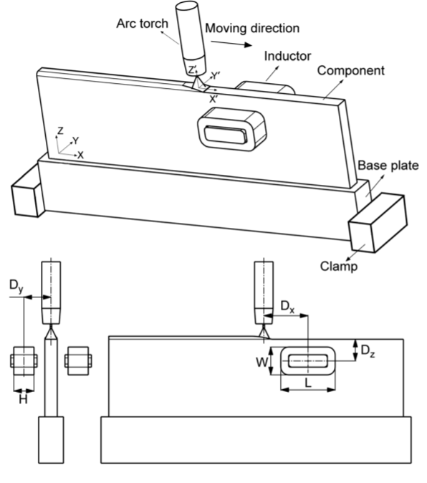

**Fig.8. Heating localized to the weld pool [49].**

It includes cooling localized to the weld pool, heating localized to the weld pool, heating of wire and heating/cooling of the build volume [46]. Heat treatment process are widely used to increase microhardness, reduce residual stress and enhancing material strength. Weld pool cooling can be achieved by using a thermoelectric cooling device that maintains the stable heat dissipation value without reducing the wire feed speed and heat input. By providing forced convective cooling behind the weld torch, here the coolant media may be water, solid CO2, etc. [47][48]. Heating localized to the weld pool can be achieved by a set up with symmetric induction coils mounted ahead and behind the weld torch as shown in fig.8. [49], and by preheat the deposit with another plasma torch ahead of the bead deposition. Cooling of build volume can be achieved by integrated conformal cooling channels on the substrate platform [50]. Selection of heat treatment process may change based on alloying elements.

**4.2 Inter pass cold rolling process**

Fig.9. shows high pressure inter pass cold rolling process. Rolling process can be carried out immediately after the deposition of each layer. A slotted roller is used to apply high pressure on the deposited layer, which refines the microstructure of the deposited material. The main purpose of inter pass rolling is to reduce the residual stresses and to obtain the homogeneous material properties. Healing of hydrogen porosity in WAAM process can be possible with inter pass rolling. This technique is applicable for simple structures, thin walls, because of its geometrical limitations.

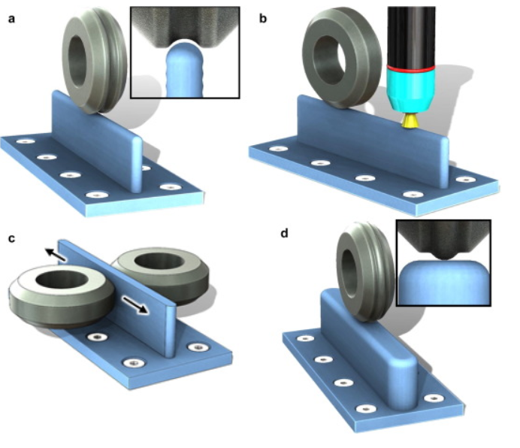

**Fig.9. Schematic diagram of the main rolling methods: (a) vertical with a profiled roller (b) in-situ rolling (c) pinch rolling (d) rolling with an inverted profiled roller for thick sections and intersections [51].**

**4.3 Inter pass cooling process**

Fig.10. represents schematic diagram of WAAM system using inter pass cooling process. It mainly contains moving gas nozzle, which supplies cooling gases such as argon, carbon dioxide and nitrogen gas. After completion of each deposit layer, moving nozzle can passes above the deposited surface to provide the cooling effect. This rapid cooling can improve the microstructure and mechanical properties of deposit [35].

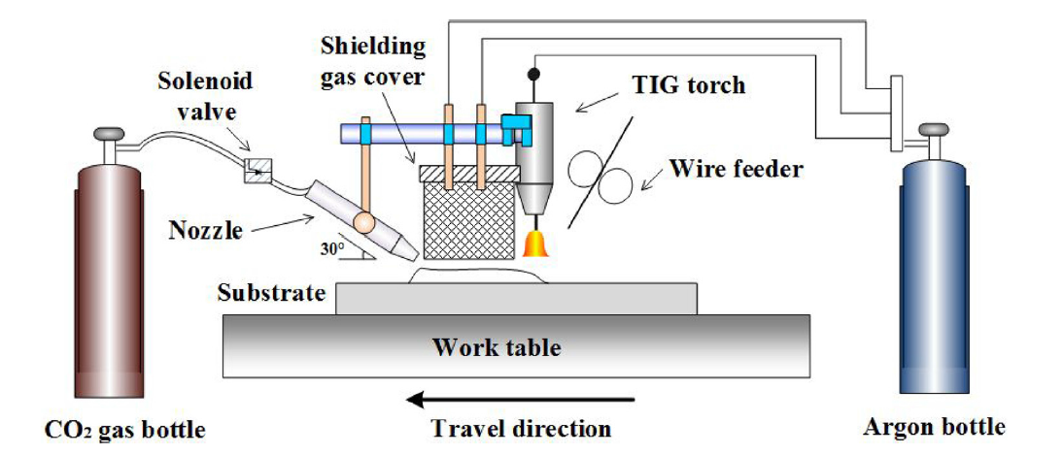

**Fig.10. Inter pass cooling in WAAM process [37].**

**4.4 Peening process**

This process is mainly used to improve mechanical properties and to reduce the local residual stress [52]. It is a cold mechanical treatment, in which tensile stress is reduced by applying compressive stress at the treatment surface. Due to the effect of peening process, the compressive stress developed at a limited depth below the component surface. for example, in carbon steels this depth is around 1mm-2mm [53]. This method is suitable for small components deposited by WAAM but it has negligible effect on large deposited materials.

**4.5 Weld pool oscillation process**

Electromagnetic arc oscillations play major role in this process. Modification of grain structure and solidification cracking tendency has affected directly by the electromagnetic arc oscillations. One or more oscillators can be used to produce arc oscillations. This process is most effective to apply in circular or transvers direction to the deposition [54]. Fig.11. indicates the electromagnetic arc oscillation process.

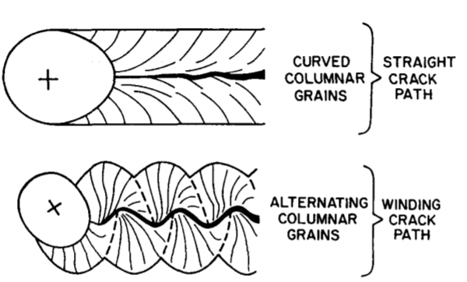

**Fig.11. Schematic sketches showing the effect of grain structure on crack path and resistance to crack propagation during welding. The centre of the arc is indicated by "+" and the welding direction is from right to left [54].**

**5 Wire arc additive manufacturing of aluminum alloys**

Most of the current researchers and industries like aerospace and transportation have focused on aluminum, titanium and steel alloys in WAAM process. Aluminum has less weight to strength ratio. WAAM is justifiable for complex and large sized components of aluminum due to less manufacturing cost of simple and small aluminum components by other conventional process [55]. Cranfield university has developed large sized aluminum ribs and cones [56]. Porosity, cracks and oxidation film are the main defects which makes difficult to implement traditional welding to WAAM of aluminum. Fig.12,13 shows the effect of pores and cracks in aluminum deposited materials.

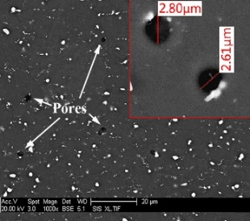 

**Fig.12. Electron microscopy Fig.13. Solidification cracking in**

**scanned pores [57]. aluminium welding [58].**

**5.1 TIG welding based WAAM of aluminum**

In TIG based WAAM process, Separate material input and energy input results in smooth deposition layers [59]. Heat input is the main factor to obtain the smooth appearance and uniform sized layers. Haibin Geng et al. [59] conducted experiments with 5A06 aluminium alloy by changing input energy(current), wire feed speed and travel speed. Minimum surface waviness is observed at a current of 132 A and maximum value obtained at a current of 164 A. Haibin Geng et al. [60] developed a mathematical model based on Fourier law of heat conduction and energy conservation for appropriate inter pass temperature. As inter pass temperature increases from room temperature up to 120°C, surface smoothness of the deposited layer also increased. Further increase in inter pass temperature causes defects because of more accumulation of heat energy. Haibin Geng et al. [61] discovered that the start position shift increases when wire fed angle increases from 10° to 20° and also it increases when wire vertical adjusting tolerance between deposited layer and tip of feed wire increases from 0 mm to 1 mm. Fig.14. indicates the gap defects caused by start position shift.



**Fig.14. Gap defects [61].**

Many researchers have done experiments and adopted process modifications to improve the microstructure and mechanical properties of aluminium and its alloys. Haibin Geng et al. [62] have showed that the tensile strength of Al-5A06 WAAM deposited material is isotropic in horizontal and vertical direction. J. Y. Bai et al. [63] conducted experiment on 2219 aluminium alloy WAAM deposited material and discovered that the deposited material has uniform strength property and also concluded that θ phases are the reason behind cracks. Z. Qi et al. [64] have builded Al-Cu-Mg component by two wire variable polarity (VP)-GTAW method and conclude that micro hardness of as deposited component can be improved with increasing in Mg concentration but there is a reduction in plasticity. Z. Qi et al. [65] have done heat treatment process on WAAM deposited 2024 aluminium alloy component and concluded that the average micro hardness value has increased and elongation and strength in horizontal direction can be improved by heat treatment process. Rujian Sun et al. [66] done laser shock peening (LSP) treatment on TIG-WAAM deposited AL-2319 component. Fig.15. shows magnified images of scanning electron microscopy (SEM) results before and after LSP. Fig.13a. is morphology of specimen before LSP and Fig.13b-Fig.13d are magnified portions of Fig13a. Fig.13e. is morphology of specimen after LSP and Fig.13f-Fig.13h. are the magnified portions of Fig.13e. From the SEM morphology it has concluded that after LSP deposited material grain size decreases from 59.7µm to 46.7µm, micro hardness value increased and residual stress converted from tensile nature to compressive nature.

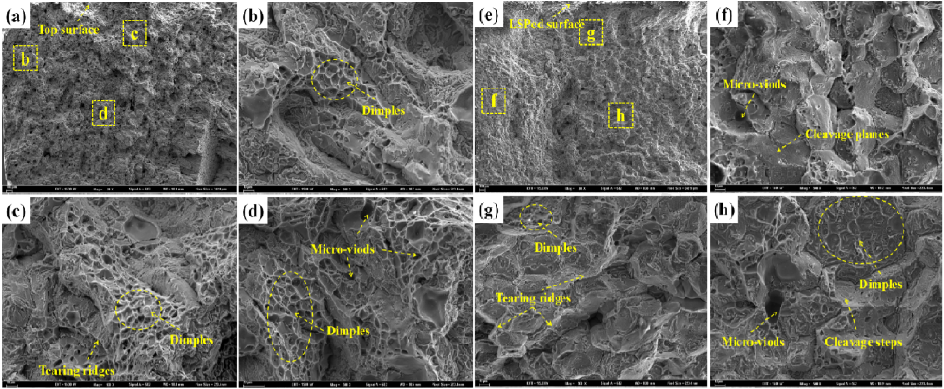

**Fig.15. SEM fracture morphologies of specimens, a-d Before LSP and e-h after LSP**

**5.2 MIG welding based WAAM of aluminum**

Deposition rate of aluminum in MIG-WAAM is around 1kg/hr. In MIG-WAAM process metal droplet transfer and electric arc are the main factors which influences quality of fabricated material [67]. Luo Yi et al. [67] conducted experiment on WAAM deposited AL-ER4043 material and showed, the manufacturing efficiency is more for pulsed arc as compare with the non-pulsed arc and also concluded that the pulsed arc MIG based WAAM process is most suitable for aluminium metal and its alloys. Wei Zuo et al. [68] have manufactured AL-5356 alloy component with TIG-MIG hybrid WAAM process and found β-phases between the layers and by doing heat treatment up to 450°c these β-phases were eliminated and all the mechanical properties has increased but ductility decreases with increase in temperature due to heat treatment process. Fig.16. Indicates micro structure before and after heat treatment. 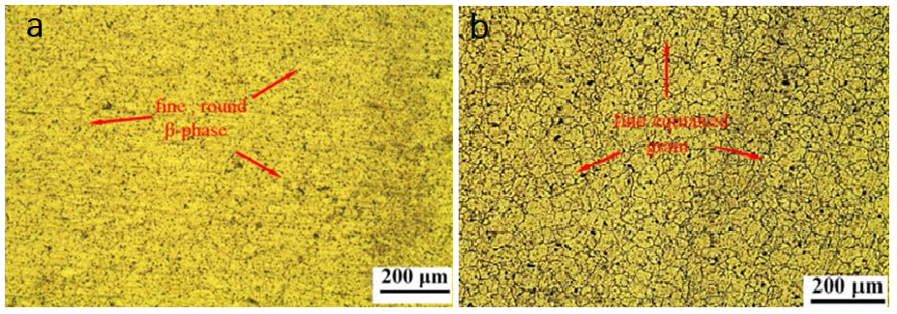

**Fig.16. Optical microstructure of AL-5356 (a)before heat treatment and (b)after heat treatment [68].**

Amberlee Haselhuhn et al. [69] have done experiment with different aluminium alloy WAAM deposited materials such as ER1100, ER4043, ER4943, ER4047, and ER5356 and concluded that when considering strength and porosity, 4000 series exhibited better performance than other series. A.Horgar et al. [70] have observed WAAM deposited AA5183 aluminium alloy material and concluded that in addition to porosity, some additional cracks have developed in the preheated zone of already deposited layers while depositing next layers. Porosity and cracks are the main drawbacks which limits the applications of aluminium alloys. The effect of porosity and cracks can be reduced or completely eliminated by adopting advanced techniques such as cold metal transfer (CMT).

**5.3 CMT based WAAM of aluminum**

The main problem with aluminum is reduction in strength at the weld and heat affected zone because of high energy input [71]. Compare with other conventional methods, CMT is more preferable for fabrication of aluminum and its alloys because of its low energy input, stable arc, high deposition rate and no spatter [72] [73]. Elrefaey. A [74] have concluded that joints produced by CMT process have better mechanical properties than conventional MIG and TIG process and also proved that CMT process produced 7075-T6 joints without cracks, spatter and low porosity. C. M. A. Silva et al. [75] conducted experiment for effect of formability on AA5083 aluminium deposit and concluded that intermediate forming operations can improve the material strength by promoting closure of voids. CMT process further developed in to pulsed-CMT (CMT-P), advanced-CMT (CMT-ADV), and pulsed advanced-CMT (CMT-PADV). Baoqiang Cong et al. [76] compared the microstructure and pore distribution for 2319-Al deposited wall mode and block mode with CMT-P and CMT-ADV processes. Less number of pores generated in block structure compare with wall structure and porosity reduced in CMT-ADV process compared to CMT-P process. Fig.17. shows the presence of pores of aluminium wall and block for CMT-P and CMT-ADV process.

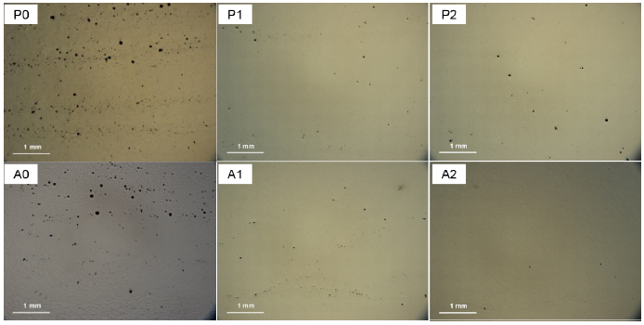

**Fig.17. Optically observed porosity of 2319-Al deposit. Where P0,A0-wall samples and P1,P2,A1,A2-block samples. P0,P1,P2- produced by CMT-P and A0,A1,A2-produced by CMT-ADV [76].**

Baoqiang Cong et al. [77] compared the porosity characteristic of AA2319 aluminium deposit for different modes of CMT such as conventional CMT, CMT-P, CMT-ADV, and CMT-PADV and proved that different arc modes of CMT influences porosity, and CMT-PADV is the best method for WAAM of aluminium components. Jianglong Gu et al. [78] observed the effect of interlayer rolling on CMT-P-WAAM deposited Al-ER5087 component and concluded that yield strength, ultimate tensile strength and micro hardness have grown linearly but no change in elongation. Jianglong Gu et al. [79] showed the influence of wire properties on Al-ER4043 deposit, deposited by CMT-PADV based WAAM process. Quality of wire has influenced the deposition stability. Smooth and clean wires improved wire feed stability. Jianglong Gu et al. [80] experimented on CMT-PADV deposited Al-2319 aluminium alloy component and concluded that as compared to CMT-P, CMT-PADV process eliminated porosity, lower heat input can refine the grain structure, and evenly distributed yield strength, ultimate tensile strength and elongation has observed. Chen Zhang et al. [81] applied vibrations during WAAM deposition of aluminium alloy. Fig.18. shows electron back scattered diffraction (EBSD) results for grain orientation distribution. Fig.18.a-d indicates grain morphology Fig.18.e-h indicates grains distribution with size less than 20µm. Finer grain zone observed at inter layers of non-vibrated deposited material which can be seen in Fig.18.e. when vibration acceleration increases more than 15 m/s2, finer grain zone disappears as shown in Fig.18.h and found 22.5% reduction in average grain size as compared to non-vibrating WAAM deposit, decreases size of pores, and reduces porosity from 6.66% to 1.52%.



**Fig.18. EBSD results (a-d) grain morphology (e-h) blue dots indicating grains size less than 20µm. (a & e): sample 1 with vibration acceleration (VA)= 0 m/s2; (b & f): sample 2 with AV=10 m/S2; (c & g): sample 3 with AV=15 m/s2; (d & h): sample 4 with AV=20m/s2.**

**6 Problems associated with WAAM of aluminium**

The main challenges facing while doing WAAM of aluminium and its alloys are 1) Porosity [80]: Certain amount of hydrogen is required to nucleate the bubbles generated in weld pool. When the hydrogen content exceeds required level causes porosity. It leads to low mechanical strength of as-deposited component, 2) Tensile residual stress [66]: It is the stress developed when there is no external force acting on deposited material, which influence the fatigue strength and mechanical properties. 3) Cracks and deformation [81]: Cracks will develop when residual stress value exceeds ultimate tensile strength of material. Deformation will develop when residual stress is in between ultimate strength and yield strength, 4) Delamination [4]: It is a separation of layers adjacent to each other in a deposited material. Its mainly due to improper re-melting of underlying layer while depositing new layer of metal, 5) Conventional WAAM can’t suitable for producing special alloy components of aluminium and its alloys, for that purpose its compulsory to go for twin wire method [1], and 6) Development of turbulent weld pool while depositing aluminium 7xxx and 6xxx series [4].

**7 Conclusion**

WAAM is an automatic manufacturing process which is controlled by computer control system. It is most suitable for producing components with complex and irregular shapes. Already existed welding techniques can be used to deposit metal. Metal deposition rate depends up on type of welding technique adopted and heat input. WAAM can affectively apply where less utilisation of material and less total cost of component is required. WAAM components mostly suffered with residual stresses, porosity and delamination. Most of the researchers have focussed on porosity phenomenon. Further research on residual stresses and delamination defects will improve its capability.

**8 References**

1. Ding, D., Pan, Z., van Duin, S., Li, H., & Shen, C. (2016). Fabricating superior NiAl bronze components through wire arc additive manufacturing. *Materials*, *9*(8), 652.
2. Suryakumar, S., Karunakaran, K. P., Bernard, A., Chandrasekhar, U., Raghavender, N., & Sharma, D. (2011). Weld bead modeling and process optimization in hybrid layered manufacturing. *Computer-Aided Design*, *43*(4), 331-344.
3. Williams, S., & Martina, F. (2015). *Wire+ arc additive manufacturing vs. traditional machining from solid: a cost comparison*. Technical report. Welding Engineering and Laser Processing Centre, Cranfield University.
4. Wu, B., Pan, Z., Ding, D., Cuiuri, D., Li, H., Xu, J., & Norrish, J. (2018). A review of the wire arc additive manufacturing of metals: properties, defects and quality improvement. *Journal of Manufacturing Processes*, *35*, 127-139.
5. Rodrigues, T. A., Duarte, V., Miranda, R. M., Santos, T. G., & Oliveira, J. P. (2019). Current Status and Perspectives on Wire and Arc Additive Manufacturing (WAAM). *Materials*, *12*(7), 1121.
6. Ding, D., Pan, Z., Cuiuri, D., & Li, H. (2015). A multi-bead overlapping model for robotic wire and arc additive manufacturing (WAAM). *Robotics and Computer-Integrated Manufacturing*, *31*, 101-110.
7. Ding, D. H., Pan, Z. X., Dominic, C., & Li, H. J. (2014, October). Process planning strategy for wire and arc additive manufacturing. In *International Conference on Robotic Welding, Intelligence and Automation* (pp. 437-450). Springer, Cham.
8. Ding, D., Shen, C., Pan, Z., Cuiuri, D., Li, H., Larkin, N., & van Duin, S. (2016). Towards an automated robotic arc-welding-based additive manufacturing system from CAD to finished part. *Computer-Aided Design*, *73*, 66-75.
9. Singh, P., & Dutta, D. (2001). Multi-direction slicing for layered manufacturing. *Journal of Computing and Information Science in Engineering*, *1*(2), 129-142.
10. Singh, P., & Dutta, D. (2001). Multi-direction slicing for layered manufacturing. *Journal of Computing and Information Science in Engineering*, *1*(2), 129-142.
11. Ruan, J., Eiamsa-ard, K., & Liou, F. W. (2005, January). Automatic multi-axis slicing based on centroidal axis computation. In *ASME 2005 International Design Engineering Technical Conferences and Computers and Information in Engineering Conference* (pp. 383-393). American Society of Mechanical Engineers.
12. Ding, D., Pan, Z., Cuiuri, D., Li, H., Larkin, N., & Van Duin, S. (2016). Automatic multi-direction slicing algorithms for wire based additive manufacturing. *Robotics and Computer-Integrated Manufacturing*, *37*, 139-150.
13. Zhang, J., & Liou, F. (2004). Adaptive slicing for a multi-axis laser aided manufacturing process. *Journal of Mechanical Design*, *126*(2), 254-261.
14. Singh, P., & Dutta, D. (2008). Offset slices for multidirection layered deposition. *Journal of Manufacturing Science and Engineering*, *130*(1), 011011.
15. Dunlavey, M. R. (1983). Efficient polygon-filling algorithms for raster displays. *ACM Transactions on Graphics (TOG)*, *2*(4), 264-273.
16. Park, S. C., & Choi, B. K. (2000). Tool-path planning for direction-parallel area milling. *Computer-Aided Design*, *32*(1), 17-25.
17. Rajan, V. T., Srinivasan, V., & Tarabanis, K. A. (2001). The optimal zigzag direction for filling a two-dimensional region. *Rapid Prototyping Journal*, *7*(5), 231-241.
18. Farouki, R. T., Koenig, T., Tarabanis, K. A., Korein, J. U., & Batchelder, J. S. (1995). Path planning with offset curves for layered fabrication processes. *Journal of Manufacturing Systems*, *14*(5), 355-368.
19. Wang, H., Jang, P., & Stori, J. A. (2005). A metric-based approach to two-dimensional (2D) tool-path optimization for high-speed machining. *Journal of manufacturing science and engineering*, *127*(1), 33-48.
20. Bertoldi, M., Yardimci, M., Pistor, C. M., & Guceri, S. I. (1998). Domain decomposition and space filling curves in toolpath planning and generation. In *1998 International Solid Freeform Fabrication Symposium*.
21. Dwivedi, R., & Kovacevic, R. (2004). Automated torch path planning using polygon subdivision for solid freeform fabrication based on welding. *Journal of Manufacturing Systems*, *23*(4), 278-291.
22. Jin, G. Q., Li, W. D., & Gao, L. (2013). An adaptive process planning approach of rapid prototyping and manufacturing. *Robotics and Computer-Integrated Manufacturing*, *29*(1), 23-38.
23. Ding, D., Pan, Z., Cuiuri, D., & Li, H. (2015). A practical path planning methodology for wire and arc additive manufacturing of thin-walled structures. *Robotics and Computer-Integrated Manufacturing*, *34*, 8-19.
24. Ding, D., Pan, Z., Cuiuri, D., Li, H., & Larkin, N. (2016). Adaptive path planning for wire-feed additive manufacturing using medial axis transformation. *Journal of Cleaner Production*, *133*, 942-952.
25. Busachi, A., Erkoyuncu, J., Colegrove, P., Martina, F., & Ding, J. (2015). Designing a WAAM based manufacturing system for defence applications. *Procedia Cirp*, *37*, 48-53.
26. Ding, D., Pan, Z., Cuiuri, D., & Li, H. (2015). Wire-feed additive manufacturing of metal components: technologies, developments and future interests. *The International Journal of Advanced Manufacturing Technology*, *81*(1-4), 465-481.
27. Prado-Cerqueira, J. L., Diéguez, J. L., & Camacho, A. M. (2017). Preliminary development of a Wire and Arc Additive Manufacturing system (WAAM). *Procedia Manufacturing*, *13*, 895-902.
28. Paskual, A., Álvarez, P., & Suárez, A. (2018). Study on arc welding processes for high deposition rate additive manufacturing. *Procedia Cirp*, *68*, 358-362.
29. Zhu, L., Luo, Y., Han, J., Zhang, C., Xu, J., & Chen, D. (2019). Energy characteristics of droplet transfer in wire-arc additive manufacturing based on the analysis of arc signals. *Measurement*, *134*, 804-813.
30. Haden, C. V., Zeng, G., Carter III, F. M., Ruhl, C., Krick, B. A., & Harlow, D. G. (2017). Wire and arc additive manufactured steel: Tensile and wear properties. *Additive Manufacturing*, *16*, 115-123.
31. Ma, Y., Cuiuri, D., Shen, C., Li, H., & Pan, Z. (2015). Effect of interpass temperature on in-situ alloying and additive manufacturing of titanium aluminides using gas tungsten arc welding. *Additive Manufacturing*, *8*, 71-77.
32. Nagesh, D. S., & Datta, G. L. (2010). Genetic algorithm for optimization of welding variables for height to width ratio and application of ANN for prediction of bead geometry for TIG welding process. *Applied soft computing*, *10*(3), 897-907.
33. Choi, Y. H., Lee, Y. W., Seo, J. S., Cho, S. M., & Doh, D. H. (2011). Visualizations of fluid flows in the TIG welding region for different shapes of the shield gas nozzle. *Journal of visualization*, *14*(3), 213-224.
34. Pan, Z., Ding, D., Wu, B., Cuiuri, D., Li, H., & Norrish, J. (2018). Arc welding processes for additive manufacturing: a review. In *Transactions on Intelligent Welding Manufacturing*(pp. 3-24). Springer, Singapore.
35. Wu, B., Pan, Z., Ding, D., Cuiuri, D., Li, H., & Fei, Z. (2018). The effects of forced interpass cooling on the material properties of wire arc additively manufactured Ti6Al4V alloy. *Journal of Materials Processing Technology*, *258*, 97-105.
36. Bertoldi, M., Yardimci, M., Pistor, C. M., & Guceri, S. I. (1998). Domain decomposition and space filling curves in toolpath planning and generation. In *1998 International Solid Freeform Fabrication Symposium*.
37. Ma, Y., Cuiuri, D., Shen, C., Li, H., & Pan, Z. (2015). Effect of interpass temperature on in-situ alloying and additive manufacturing of titanium aluminides using gas tungsten arc welding. *Additive Manufacturing*, *8*, 71-77.
38. Shen, C., Pan, Z., Cuiuri, D., Roberts, J., & Li, H. (2016). Fabrication of Fe-FeAl functionally graded material using the wire-arc additive manufacturing process. *Metallurgical and Materials Transactions B*, *47*(1), 763-772.
39. Ding, D., Pan, Z., Cuiuri, D., & Li, H. (2015). Wire-feed additive manufacturing of metal components: technologies, developments and future interests. *The International Journal of Advanced Manufacturing Technology*, *81*(1-4), 465-481.
40. Padilla, T. M., Quinn, T. P., Munoz, D. R., & Rorrer, R. A. L. (2003). A mathematical model of wire feeding mechanisms in GMAW. *WELDING JOURNAL-NEW YORK-*, *82*(5), 100-S.
41. Li, Y., Xiong, J., & Yin, Z. (2019). Molten pool stability of thin-wall parts in robotic GMA-based additive manufacturing with various position depositions. *Robotics and Computer-Integrated Manufacturing*, *56*, 1-11.
42. Williams, S. W., Martina, F., Addison, A. C., Ding, J., Pardal, G., & Colegrove, P. (2016). Wire+ arc additive manufacturing. *Materials Science and Technology*, *32*(7), 641-647.
43. Zhang, C., Li, Y., Gao, M., & Zeng, X. (2018). Wire arc additive manufacturing of Al-6Mg alloy using variable polarity cold metal transfer arc as power source. *Materials Science and Engineering: A*, *711*, 415-423.
44. Cong, B., Ding, J., & Williams, S. (2015). Effect of arc mode in cold metal transfer process on porosity of additively manufactured Al-6.3% Cu alloy. *The International Journal of Advanced Manufacturing Technology*, *76*(9-12), 1593-1606.
45. Prado-Cerqueira, J. L., Diéguez, J. L., & Camacho, A. M. (2017). Preliminary development of a Wire and Arc Additive Manufacturing system (WAAM). *Procedia Manufacturing*, *13*, 895-902.
46. Cunningham, C. R., Flynn, J. M., Shokrani, A., Dhokia, V., & Newman, S. T. (2018). Invited review article: Strategies and processes for high quality wire arc additive manufacturing. *Additive Manufacturing*, *22*, 672-686.
47. Wells, M. E., & Lukens, W. E. (1986). Effect of forced gas cooling on GTA weld pools. *Welding Journal*, *65*(12), 314-321.
48. Van der Aa, E. M. (2007). Local cooling during welding: prediction and control of residual stresses and buckling distortion.
49. Bai, X., Zhang, H., & Wang, G. (2015). Modeling of the moving induction heating used as secondary heat source in weld-based additive manufacturing. *The International Journal of Advanced Manufacturing Technology*, *77*(1-4), 717-727.
50. Lu, X., Zhou, Y. F., Xing, X. L., Shao, L. Y., Yang, Q. X., & Gao, S. Y. (2017). Open-source wire and arc additive manufacturing system: formability, microstructures, and mechanical properties. *The International Journal of Advanced Manufacturing Technology*, *93*(5-8), 2145-2154.
51. Colegrove, P. A., Donoghue, J., Martina, F., Gu, J., Prangnell, P., & Hönnige, J. (2017). Application of bulk deformation methods for microstructural and material property improvement and residual stress and distortion control in additively manufactured components. *Scripta Materialia*, *135*, 111-118..
52. Sun, R., Li, L., Zhu, Y., Guo, W., Peng, P., Cong, B., ... & Liu, L. (2018). Microstructure, residual stress and tensile properties control of wire-arc additive manufactured 2319 aluminum alloy with laser shock peening. *Journal of Alloys and Compounds*, *747*, 255-265.
53. Cheng, X., Fisher, J. W., Prask, H. J., Gnäupel-Herold, T., Yen, B. T., & Roy, S. (2003). Residual stress modification by post-weld treatment and its beneficial effect on fatigue strength of welded structures. *International Journal of Fatigue*, *25*(9-11), 1259-1269.
54. Kou, S., & Le, Y. (1985). Grain structure and solidification cracking in oscillated arc welds of 5052 aluminum alloy. *Metallurgical Transactions A*, *16*(7), 1345-1352.
55. Brice, C., Shenoy, R., Kral, M., & Buchannan, K. (2015). Precipitation behavior of aluminum alloy 2139 fabricated using additive manufacturing. *Materials Science and Engineering: A*, *648*, 9-14.
56. Ding, J., Colegrove, P., Mehnen, J., Ganguly, S., Almeida, P. S., Wang, F., & Williams, S. (2011). Thermo-mechanical analysis of wire and arc additive layer manufacturing process on large multi-layer parts. *Computational Materials Science*, *50*(12), 3315-3322.
57. Gu, J., Ding, J., Williams, S. W., Gu, H., Ma, P., & Zhai, Y. (2016). The effect of inter-layer cold working and post-deposition heat treatment on porosity in additively manufactured aluminum alloys. *Journal of materials processing technology*, *230*, 26-34.
58. Derekar, K. S. (2018). A review of wire arc additive manufacturing and advances in wire arc additive manufacturing of aluminium. *Materials Science and Technology*, *34*(8), 895-916.
59. Geng, H., Li, J., Xiong, J., Lin, X., Huang, D., & Zhang, F. (2018). Formation and improvement of surface waviness for additive manufacturing 5A06 aluminium alloy component with GTAW system. *Rapid Prototyping Journal*, *24*(2), 342-350.
60. Geng, H., Li, J., Xiong, J., & Lin, X. (2017). Optimisation of interpass temperature and heat input for wire and arc additive manufacturing 5A06 aluminium alloy. *Science and Technology of Welding and Joining*, *22*(6), 472-483.
61. Geng, H., Li, J., Xiong, J., Lin, X., & Zhang, F. (2017). Optimization of wire feed for GTAW based additive manufacturing. *Journal of Materials Processing Technology*, *243*, 40-47.
62. Geng, H., Li, J., Xiong, J., Lin, X., & Zhang, F. (2017). Geometric limitation and tensile properties of wire and arc additive manufacturing 5A06 aluminum alloy parts. *Journal of Materials Engineering and Performance*, *26*(2), 621-629.
63. Bai, J. Y., Yang, C. L., Lin, S. B., Dong, B. L., & Fan, C. L. (2016). Mechanical properties of 2219-Al components produced by additive manufacturing with TIG. *The International Journal of Advanced Manufacturing Technology*, *86*(1-4), 479-485.
64. Qi, Z., Cong, B., Qi, B., Sun, H., Zhao, G., & Ding, J. (2018). Microstructure and mechanical properties of double-wire+ arc additively manufactured Al-Cu-Mg alloys. *Journal of Materials Processing Technology*, *255*, 347-353.
65. Qi, Z., Qi, B., Cong, B., Sun, H., Zhao, G., & Ding, J. (2019). Microstructure and mechanical properties of wire+ arc additively manufactured 2024 aluminum alloy components: As-deposited and post heat-treated. *Journal of Manufacturing Processes*, *40*, 27-36.
66. Sun, R., Li, L., Zhu, Y., Guo, W., Peng, P., Cong, B., ... & Liu, L. (2018). Microstructure, residual stress and tensile properties control of wire-arc additive manufactured 2319 aluminum alloy with laser shock peening. *Journal of Alloys and Compounds*, *747*, 255-265.
67. Luo, Y., Li, J., Xu, J., Zhu, L., Han, J., & Zhang, C. (2018). Influence of pulsed arc on the metal droplet deposited by projected transfer mode in wire-arc additive manufacturing. *Journal of Materials Processing Technology*, *259*, 353-360.
68. Zuo, W., Ma, L., Lu, Y., Li, S. Y., Ji, Z., & Ding, M. (2018). Effects of solution treatment temperatures on microstructure and mechanical properties of TIG–MIG hybrid arc additive manufactured 5356 aluminum alloy. *Metals and Materials International*, *24*(6), 1346-1358.
69. Haselhuhn, A. S., Buhr, M. W., Wijnen, B., Sanders, P. G., & Pearce, J. M. (2016). Structure-property relationships of common aluminum weld alloys utilized as feedstock for GMAW-based 3-D metal printing. *Materials Science and Engineering: A*, *673*, 511-523.
70. Horgar, A., Fostervoll, H., Nyhus, B., Ren, X., Eriksson, M., & Akselsen, O. M. (2018). Additive manufacturing using WAAM with AA5183 wire. *Journal of Materials Processing Technology*, *259*, 68-74.
71. Wang, P., Hu, S., Shen, J., & Liang, Y. (2017). Characterization the contribution and limitation of the characteristic processing parameters in cold metal transfer deposition of an Al alloy. *Journal of Materials Processing Technology*, *245*, 122-133.
72. Pickin, C. G., & Young, K. (2006). Evaluation of cold metal transfer (CMT) process for welding aluminium alloy. *Science and Technology of Welding and Joining*, *11*(5), 583-585.
73. Schierl, A. (2005). The CMT process a revolution in welding technology. *WELDING IN THE WORLD-LONDON-*, *49*(I), 38.
74. Elrefaey, A. (2015). Effectiveness of cold metal transfer process for welding 7075 aluminium alloys. *Science and Technology of Welding and Joining*, *20*(4), 280-285.
75. Silva, C. M. A., Bragança, I. M., Cabrita, A., Quintino, L., & Martins, P. A. F. (2017). Formability of a wire arc deposited aluminium alloy. *Journal of the Brazilian Society of Mechanical Sciences and Engineering*, *39*(10), 4059-4068.
76. Cong, B., Qi, Z., Qi, B., Sun, H., Zhao, G., & Ding, J. (2017). A comparative study of additively manufactured thin wall and block structure with Al-6.3% Cu alloy using cold metal transfer process. *Applied Sciences*, *7*(3), 275.
77. Cong, B., Ding, J., & Williams, S. (2015). Effect of arc mode in cold metal transfer process on porosity of additively manufactured Al-6.3% Cu alloy. *The International Journal of Advanced Manufacturing Technology*, *76*(9-12), 1593-1606.
78. Gu, J., Wang, X., Bai, J., Ding, J., Williams, S., Zhai, Y., & Liu, K. (2018). Deformation microstructures and strengthening mechanisms for the wire+ arc additively manufactured Al-Mg4. 5Mn alloy with inter-layer rolling. *Materials Science and Engineering: A*, *712*, 292-301.
79. Gu, J. L., Ding, J. L., Cong, B. Q., Bai, J., Gu, H. M., Williams, S. W., & Zhai, Y. C. (2015). The influence of wire properties on the quality and performance of wire+ arc additive manufactured aluminium parts. In *Advanced Materials Research* (Vol. 1081, pp. 210-214). Trans Tech Publications.
80. Gu, J., Cong, B., Ding, J., Williams, S. W., & Zhai, Y. (2014, August). Wire+ arc additive manufacturing of aluminium. In *Proceedings of the 25th Annual International Solid Freeform Fabrication Symposium, Austin, TX, USA* (pp. 4-6).
81. Sames, W. J., List, F. A., Pannala, S., Dehoff, R. R., & Babu, S. S. (2016). The metallurgy and processing science of metal additive manufacturing. *International Materials Reviews*, *61*(5), 315-360.